**DAA ASSIGNMENT-4**

**Task-1:**

**Aim:**

The aim of this task is to understand the basics of source control systems by creating an account on GitHub, setting up a repository with a README file, learning the process of starting a new project, and pushing local files to the GitHub repository.

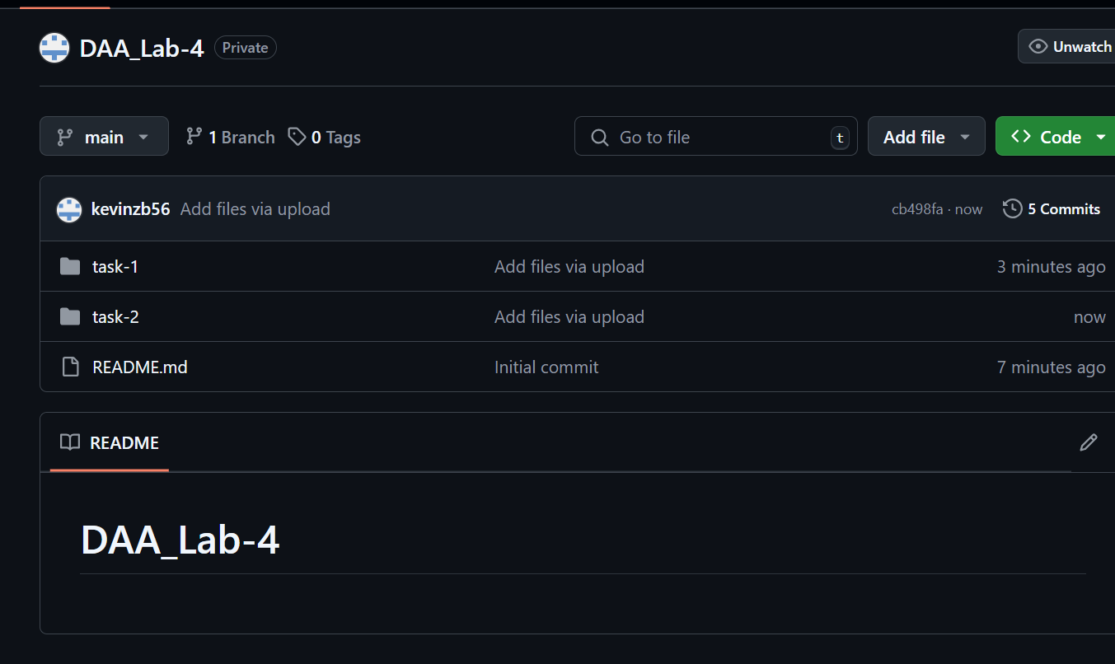

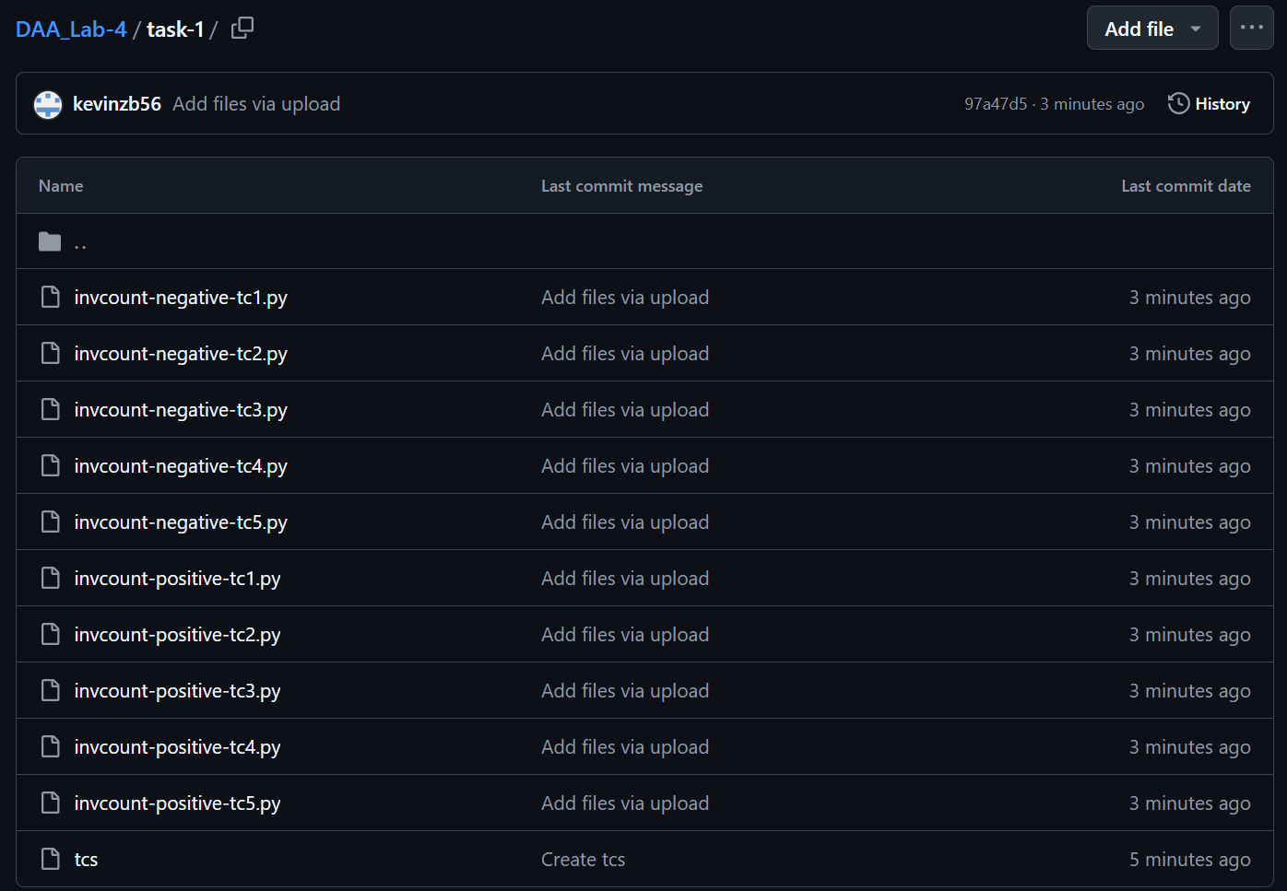

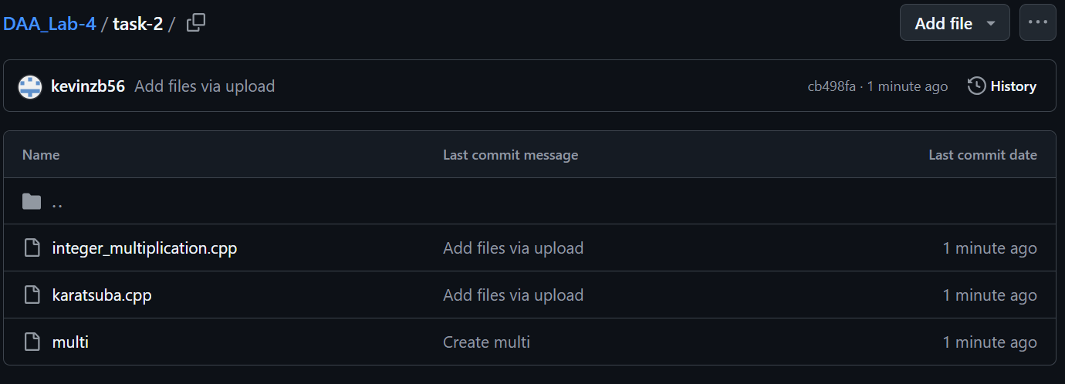

Link to the repo :- <https://github.com/kevinzb56/DAA_Lab-4>

**Conclusion**:

In this task, we successfully learned the fundamentals of using a source control system by creating a GitHub account, setting up a repository, and adding a README file. We also explored the process of initiating a new project and gained practical experience in pushing local files to the GitHub repository, reinforcing the importance of version control in software development.

**Experiment task-1:**

**Aim:**

The aim of this project is to analyze the course-code choices of 100 first- and second-year students by calculating the inversion count for each student's selections. The experiment will classify students based on their inversion counts (zero, one, two, three or more) and provide insights on the patterns observed in their preferences.

**Algorithm:**

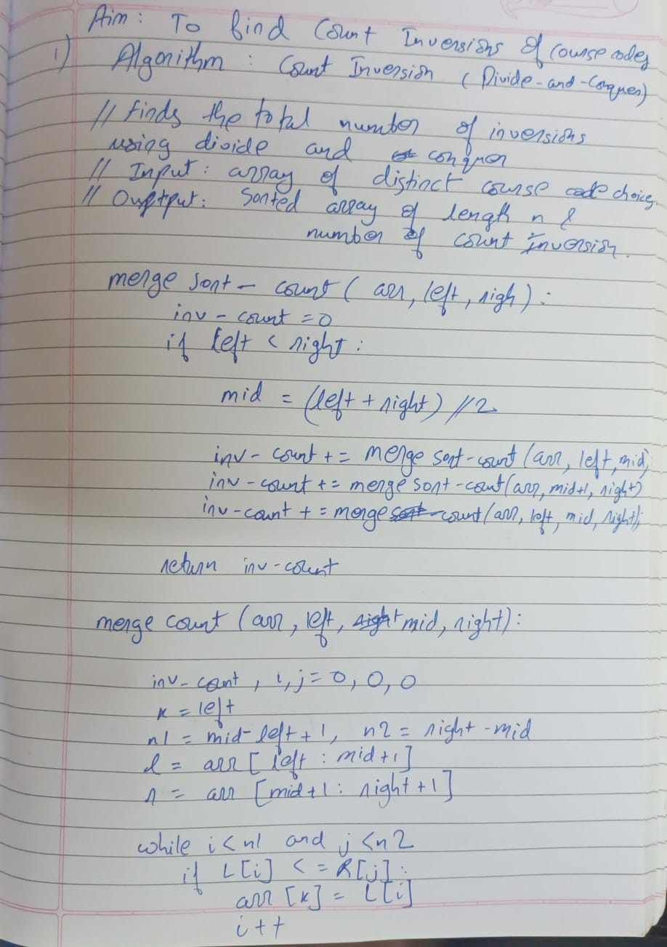

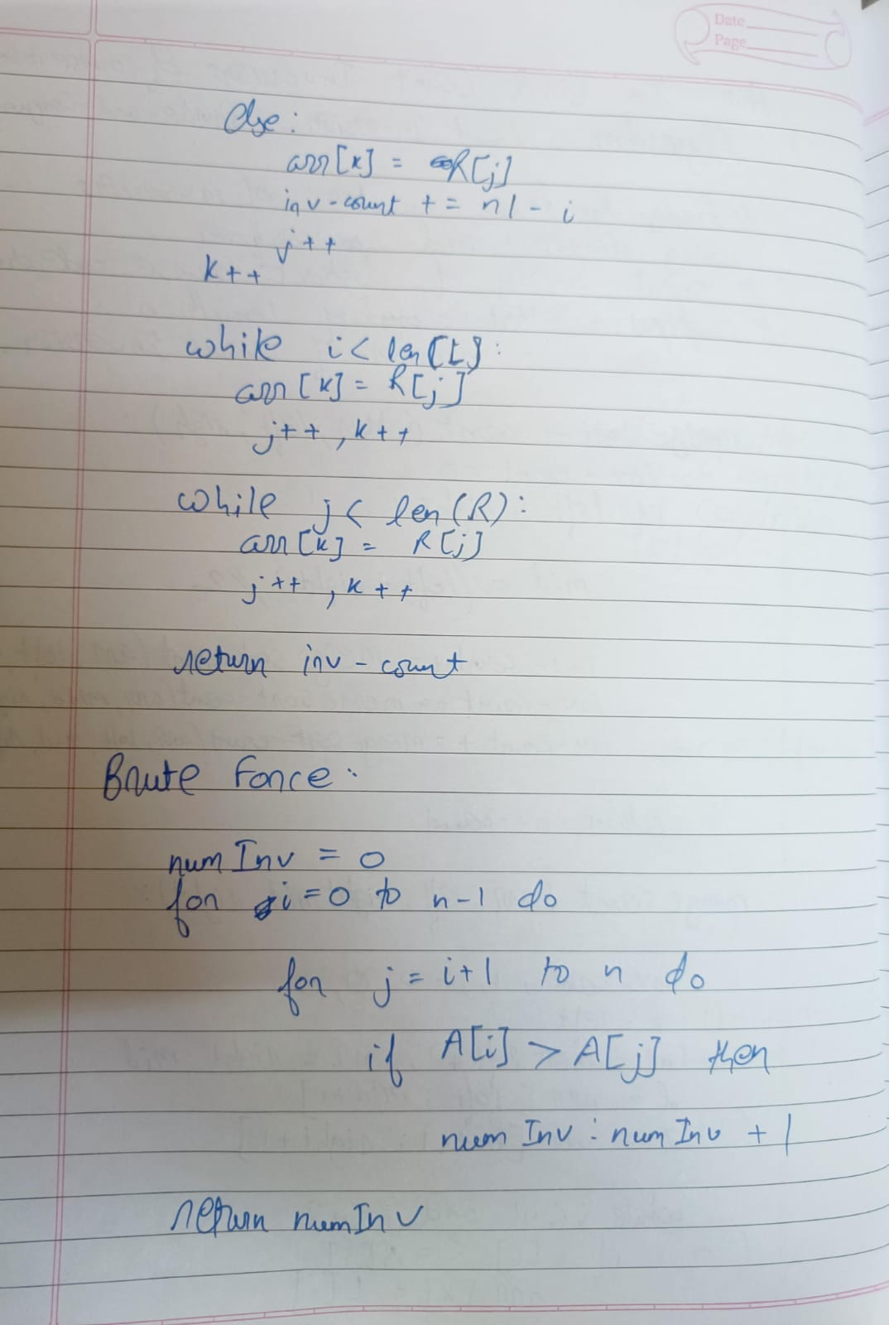

**Test cases:**

Positive:

1]

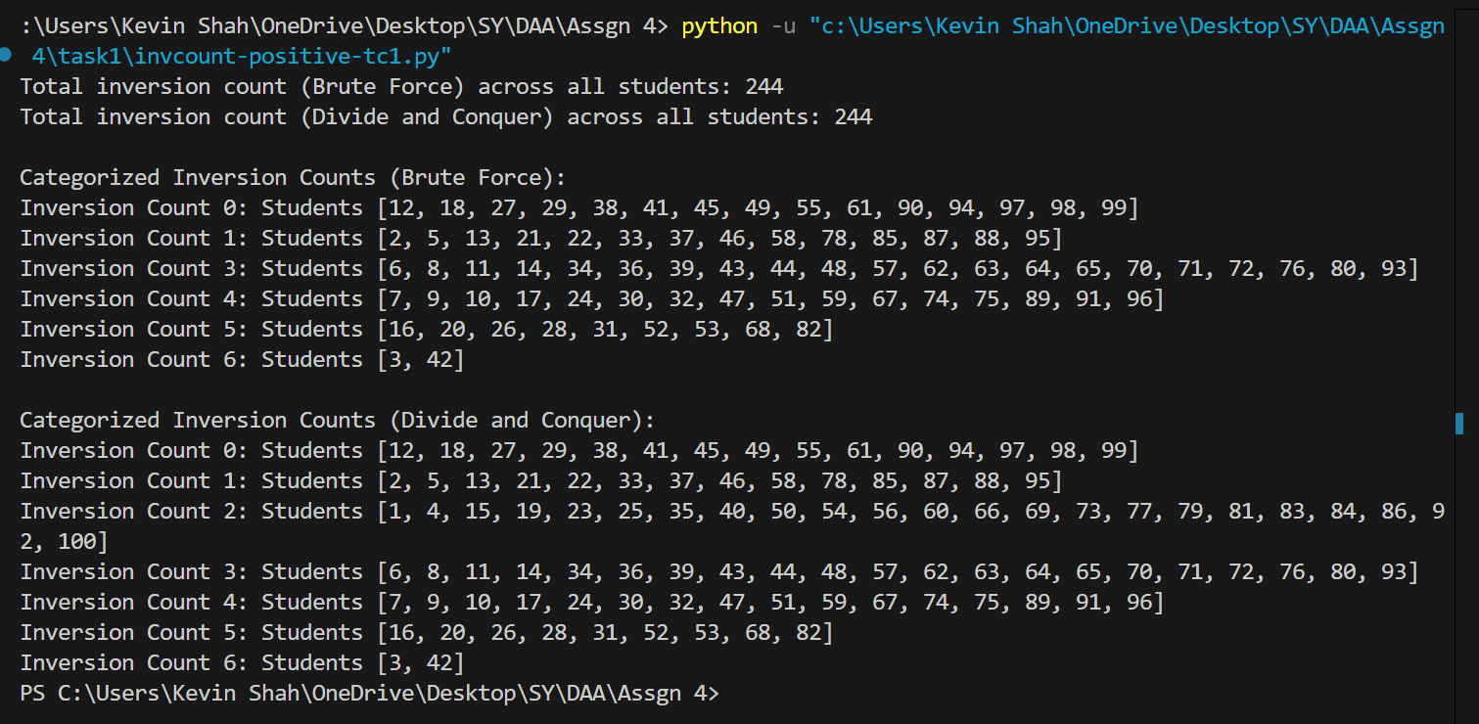

2]

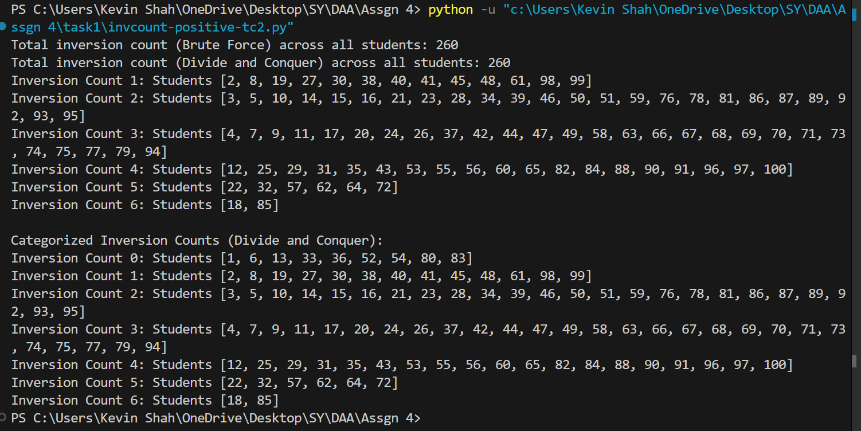

3]

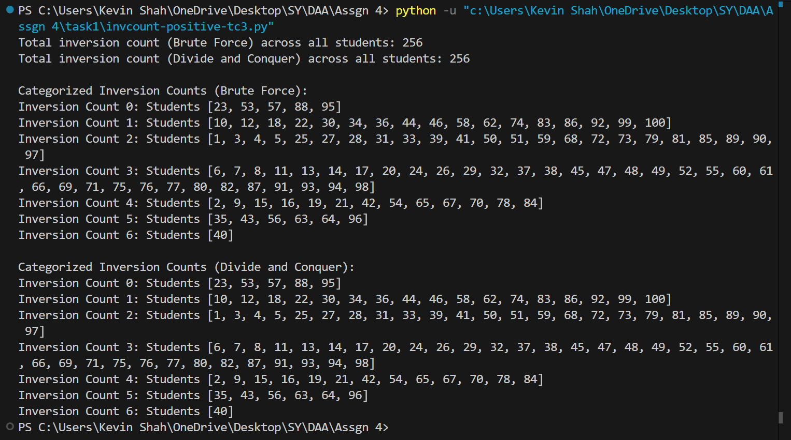

4]

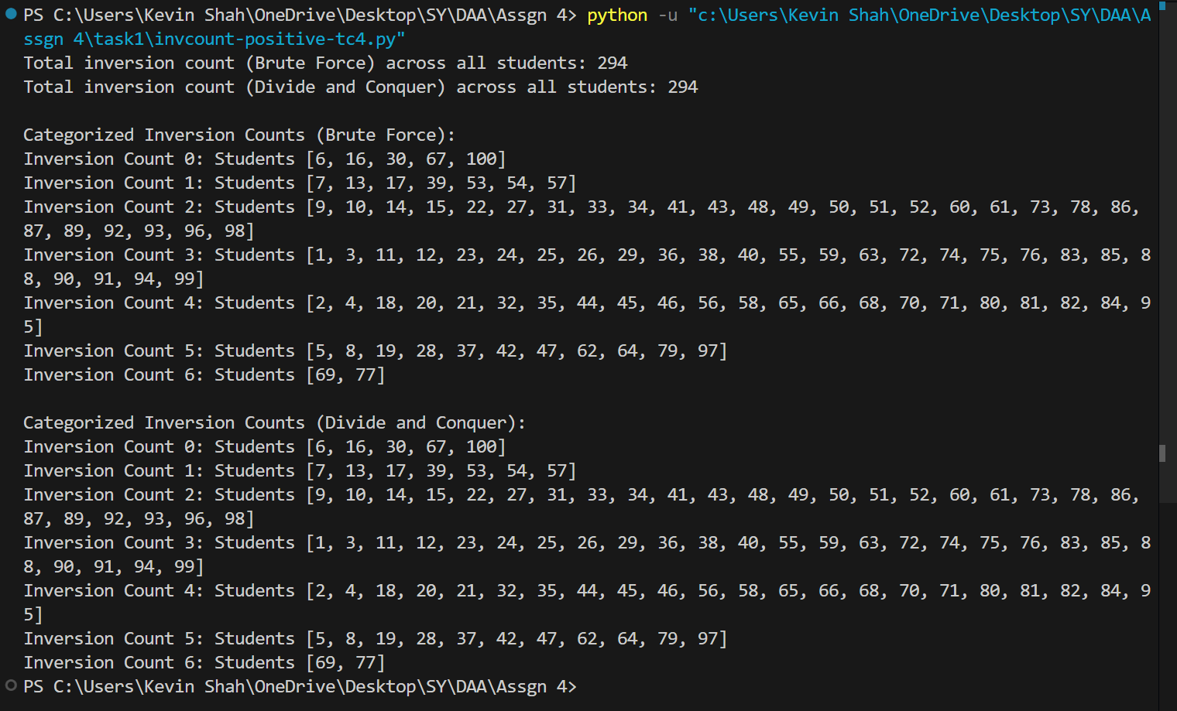

5]

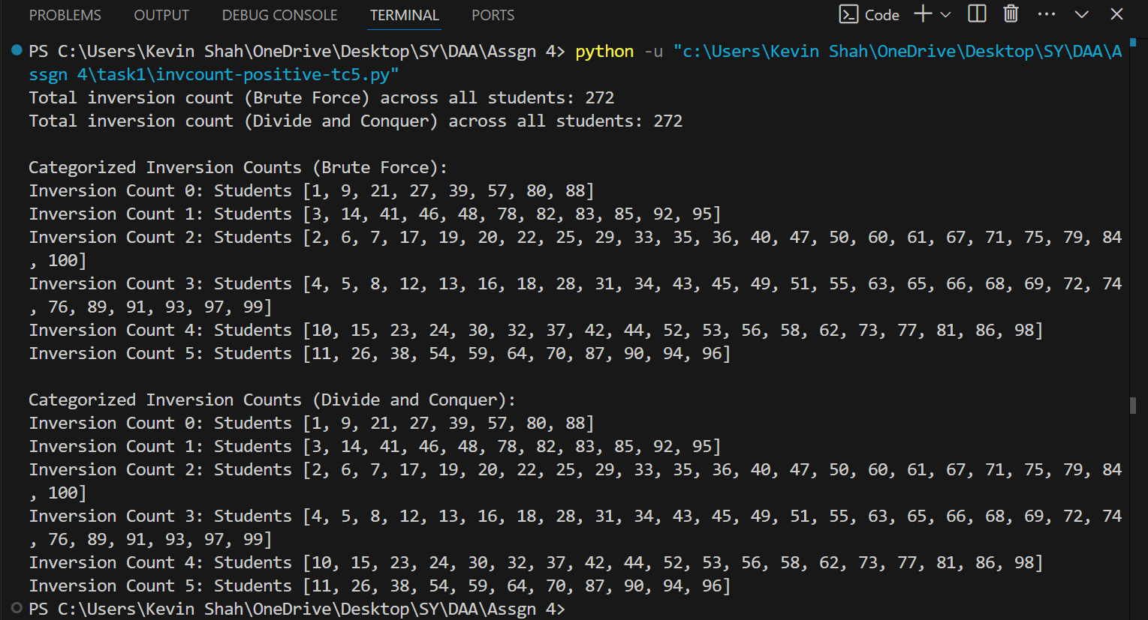

Negative:

1]

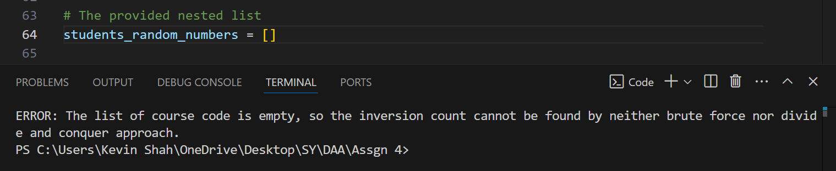

2]

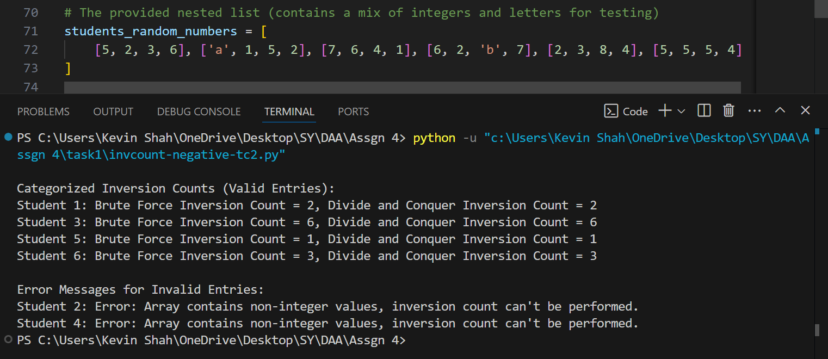

3]

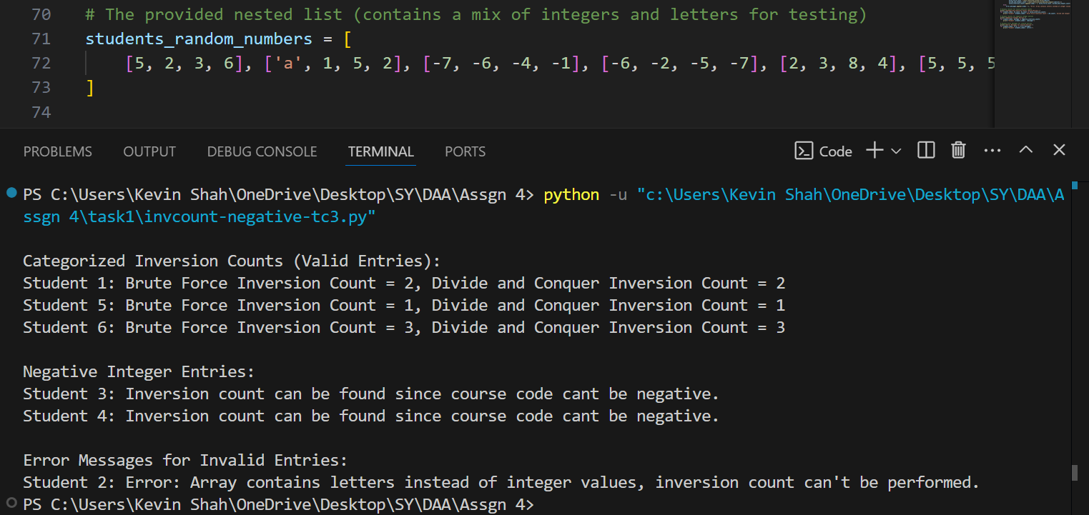

4]

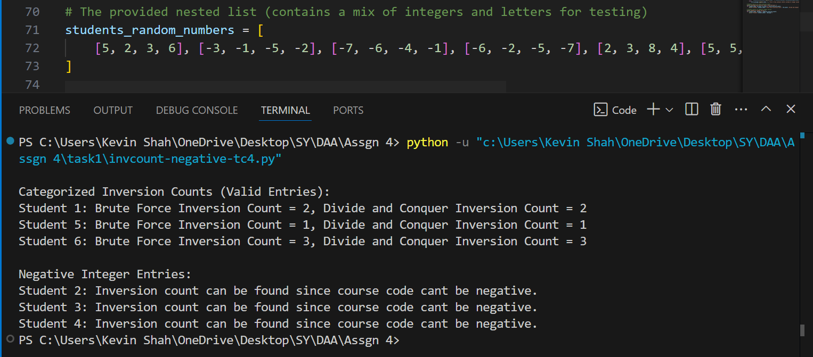

5]

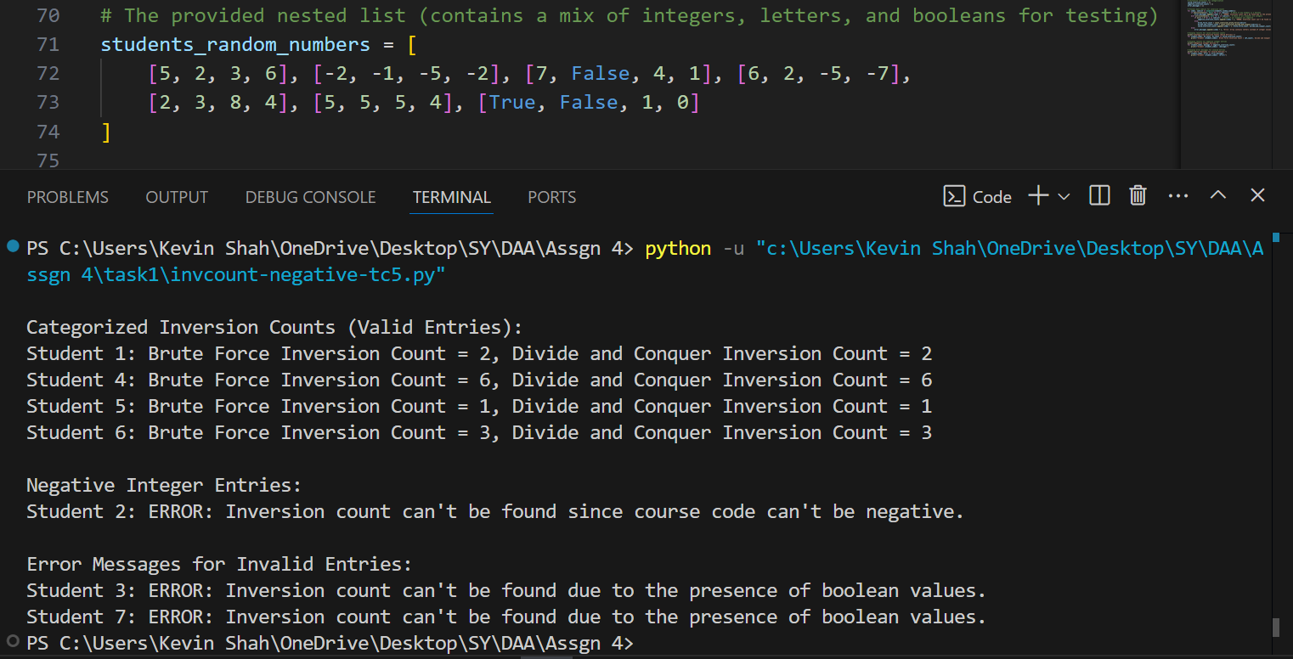

**Handwritten test cases and Time Complexity:**

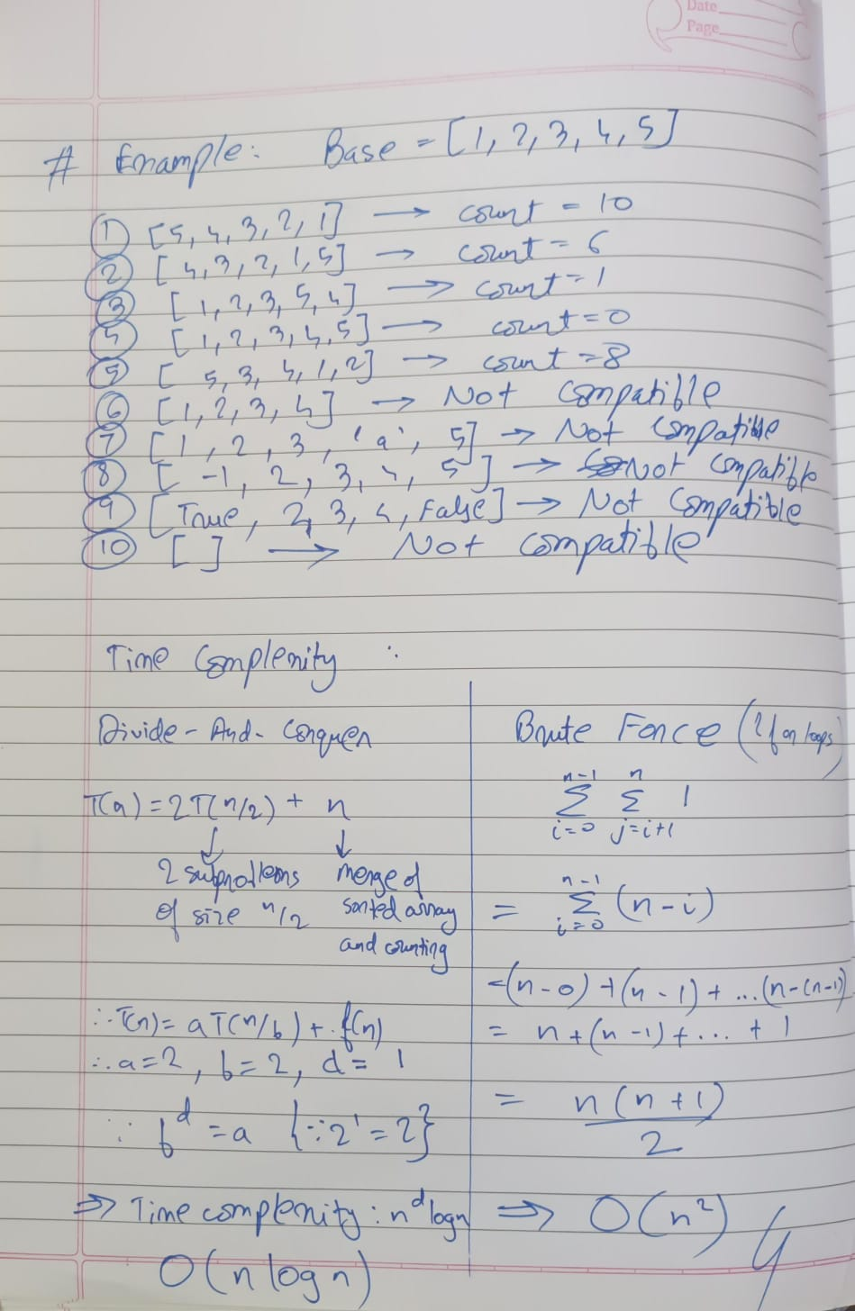

**Program**

**1)Brute Force**

# Brute force method to count the number of inversions in a list

def count_inversions_brute_force(arr):

inversions = 0

n = len(arr)

# Compare each pair (i, j) where i < j

for i in range(n):

for j in range(i + 1, n):

if arr[i] > arr[j]:

inversions += 1

return inversions

# Example usage

arr = [8, 4, 2, 1]

# Count inversions using brute force

brute_force_inversions = count_inversions_brute_force(arr)

print(f"Brute Force Inversions: {brute_force_inversions}")

**2)Divide-and-Conquer**

# Divide and conquer (merge sort) method to count the number of inversions in a list

def count_inversions_divide_and_conquer(arr):

return merge_sort(arr, 0, len(arr) - 1)

def merge_sort(arr, left, right):

if left >= right:

return 0

mid = (left + right) // 2

inversions = merge_sort(arr, left, mid)

inversions += merge_sort(arr, mid + 1, right)

inversions += merge_and_count(arr, left, mid, right)

return inversions

def merge_and_count(arr, left, mid, right):

# Left and right subarrays

left_subarray = arr[left:mid + 1]

right_subarray = arr[mid + 1:right + 1]

i = j = 0

k = left

inversions = 0

# Merge while counting inversions

while i < len(left_subarray) and j < len(right_subarray):

if left_subarray[i] <= right_subarray[j]:

arr[k] = left_subarray[i]

i += 1

else:

arr[k] = right_subarray[j]

inversions += (mid - i + 1 - left) # Count inversions

j += 1

k += 1

# Copy remaining elements

while i < len(left_subarray):

arr[k] = left_subarray[i]

i += 1

k += 1

while j < len(right_subarray):

arr[k] = right_subarray[j]

j += 1

k += 1

return inversions

# Example usage

arr = [8, 4, 2, 1]

# Count inversions using divide and conquer

divide_and_conquer_inversions = count_inversions_divide_and_conquer(arr)

print(f"Divide and Conquer Inversions: {divide_and_conquer_inversions}")

**Experiment task-2:**

**Algorithm and Test Cases:**

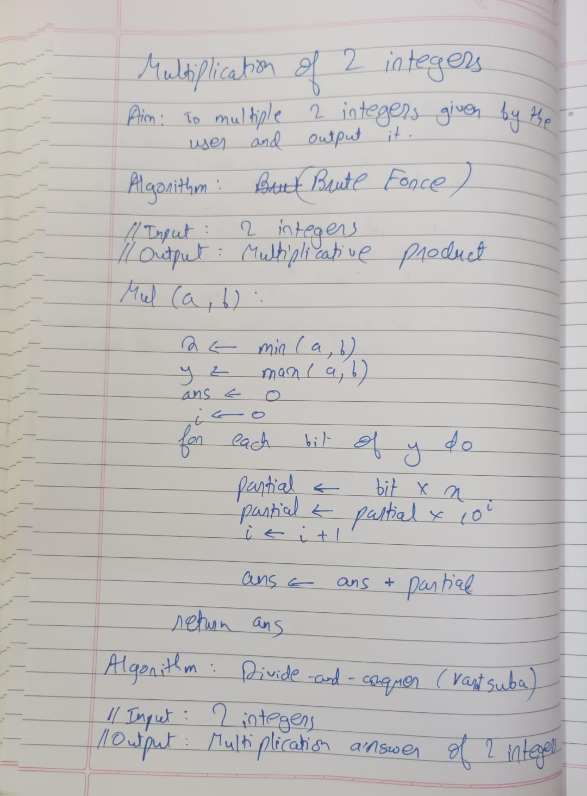

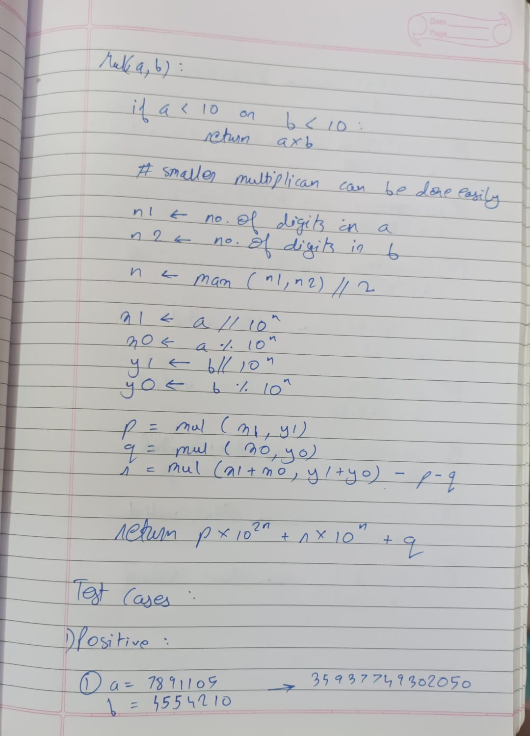

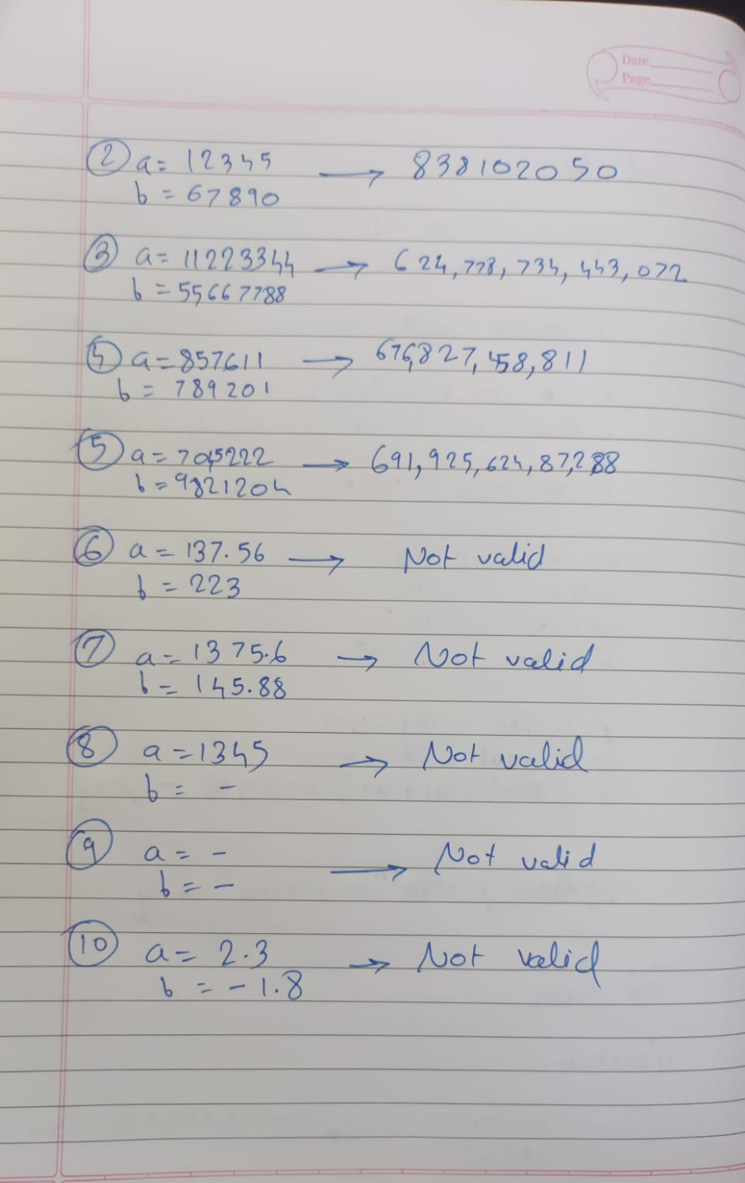

**Time Complexity:**

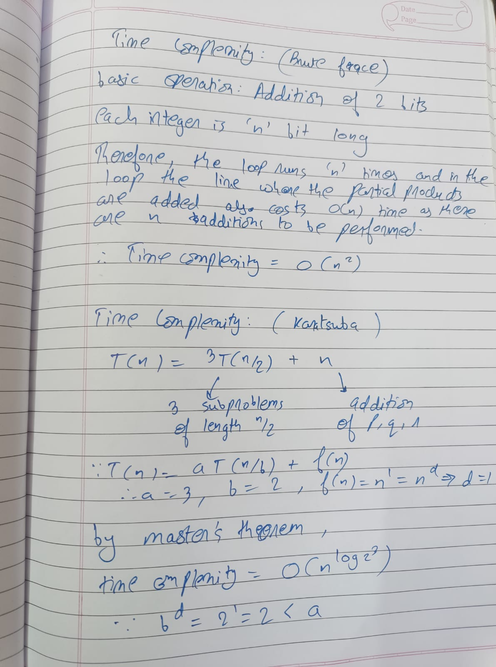

**Outputs:**

Integer Multiplication(school method):

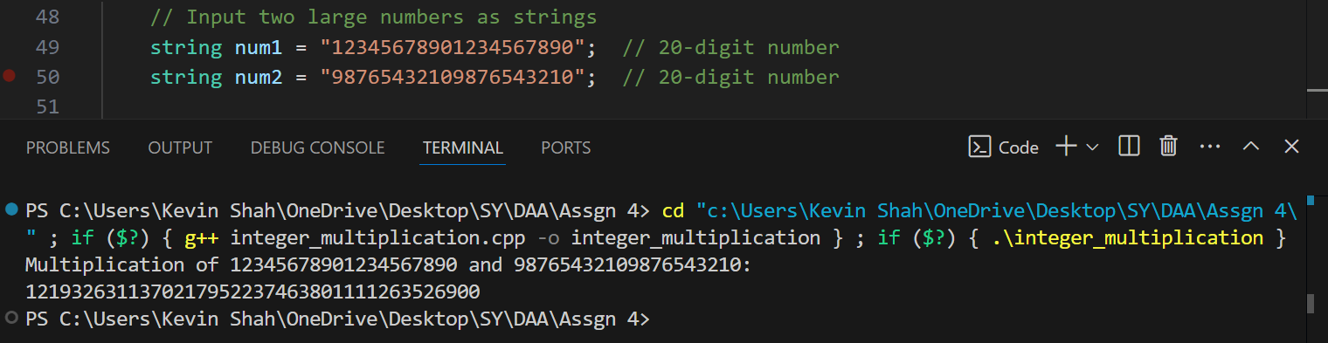

Divide-and-Conquer(Karatsuba):

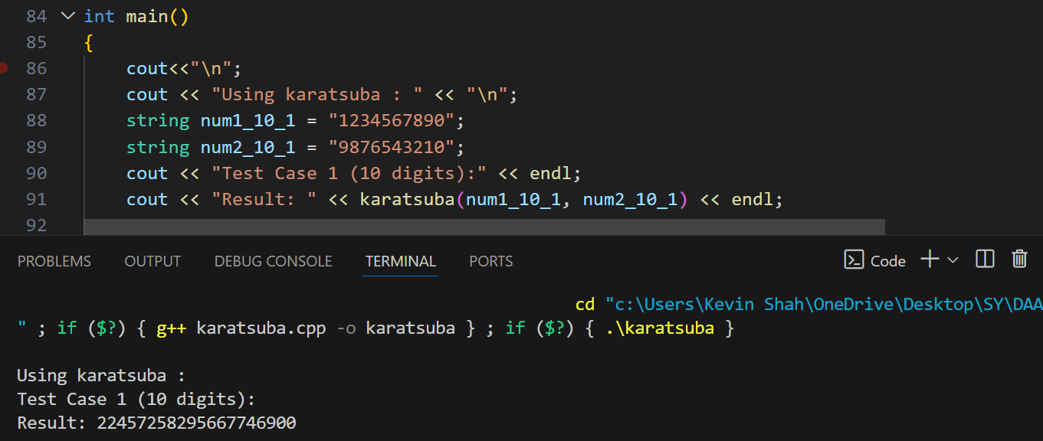

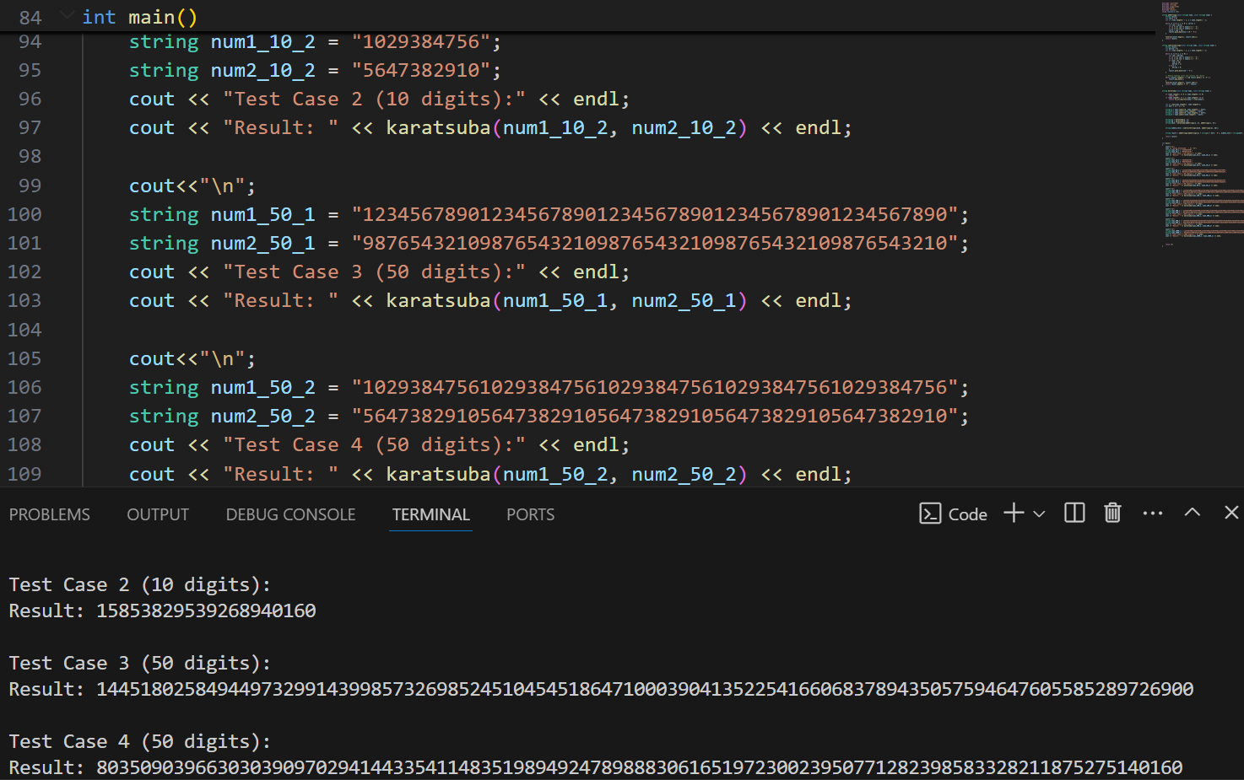

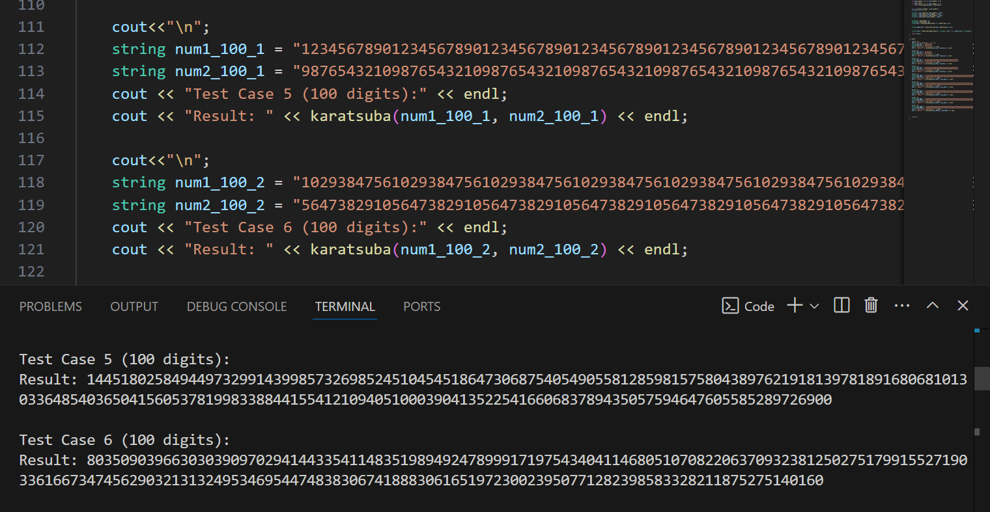

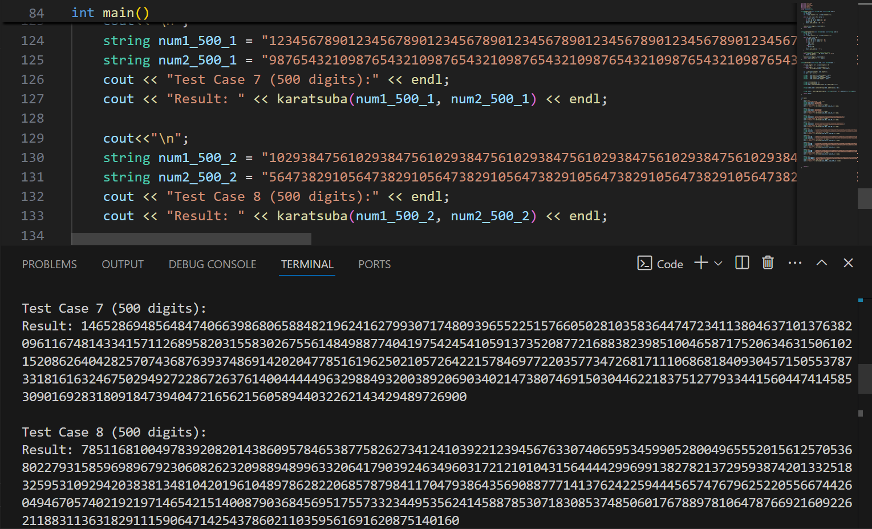

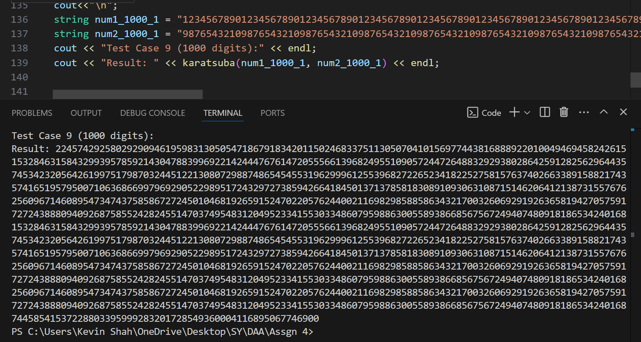

**Conclusion:**

